IEEE 802.15.1 Bluetooth

1. BLuetooth is a wireless technology standart used for exchanging data between fixed and mobile devices over short distances using short-wavelength UHF radio waves in the ISM radio bands, from 2400 to 2485 GHz and building personal area networks (PANs)
2. It was originally conceived as a wireless alternative to RS-232 data cables
3. Bluetooth is a wireless technology named after Harold Bluetooth, based on an analogy that Bluetooth technology would unite devices the way Harold Bluetooth united the tribes of Denmark into a single kingdom.
4. Bluetooth is specified by an industry consortium called the Bluetooth Special Interest group.
5. It specifies an entire suite of protocols, going beyond the link layer to define application protocols, which it calls profiles, for a range of applications.
   1. There is a profile for synchronizing a PDA with personal computer
   2. Another profile gives a mobile computer access to a wired LAN.
6. The basic Bluetooth network configuration is called a **piconet.**
   1. Consists of a master device and up to seven slave devices
   2. Any communication is between the master and a slave.
   3. The slaves do not communicate directly with each other.
   4. A slave can be parked; set to an inactive, low-power state.

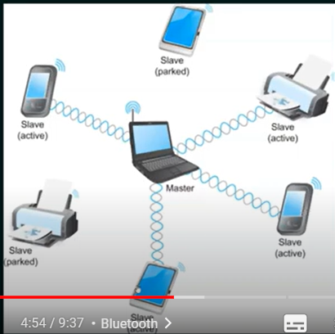

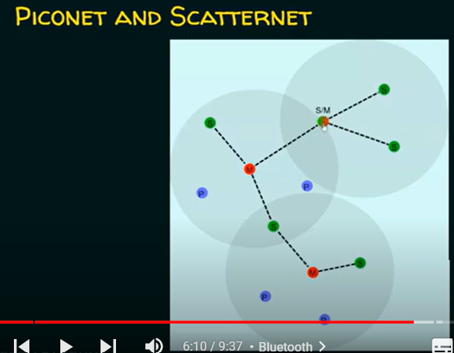

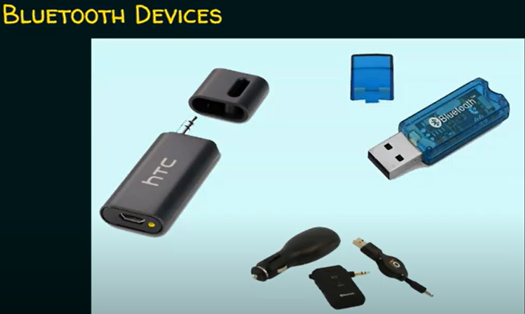

| Pros | Cons |
| --- | --- |
| Low cost | It can be hacked and hence less secure |
| Easy to use | It has slow data transfer rate |
| It can also penetrate through walls | It has small range: 10 meters |
| It creates an ad-hoc connection immediately without any wires |  |
| It is used for voice and data transfer |  |

Bluesnarfing

1. Bluesnarfing is the unauthorized access of information from a wireless device through a Bluetooth connection, often between phones, desktops, laptops, and PDAs.
2. This allows access to calendars, contact lists, emails and text messages and on some phones, users can copy pictures and private videos.
3. Bluesnarfing is the theft of information from the target device.